According to Intelli, the Greece Cardiology Devices Market was valued at USD 9,949.13 million in 2024 and is projected to reach USD 14234.46 million by 2032, growing at a CAGR of 5.48% from 2024 to 2032.

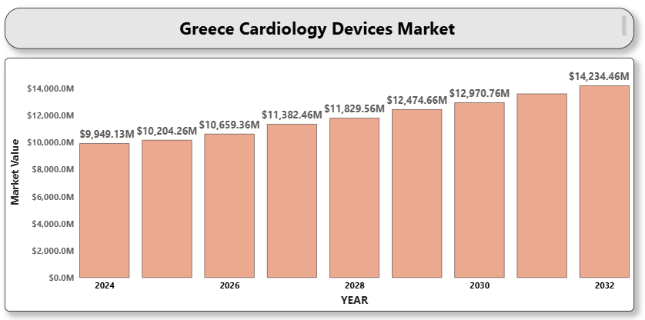

The Greece cardiology devices market is witnessing steady growth, driven by the rising incidence of cardiovascular diseases (CVDs), technological advancements in medical devices, and increasing awareness about early diagnosis and treatment of heart-related conditions. Government healthcare reforms, rising healthcare expenditure, and an aging population are major factors supporting market expansion. Additionally, the adoption of minimally invasive procedures and remote cardiac monitoring technologies are opening new avenues for growth. Multinational companies are actively introducing next-generation cardiology devices, contributing to a more competitive and innovative market landscape.

**Greece Cardiology Devices Market Definition**

Cardiology devices are instruments used for diagnosing, monitoring, and treating cardiovascular diseases. These devices include electrocardiograms (ECG), defibrillators, cardiac monitors, pacemakers, stents, heart valves, and other interventional cardiology and cardiac rhythm management products. Advancements in implantable devices, AI-powered diagnostic tools, and wearable cardiac monitors are reshaping the management of heart diseases. These devices are utilized in hospitals, ambulatory surgical centers, homecare settings, and specialized cardiac clinics.

**Greece Cardiology Devices Market Overview**

The Greece cardiology devices market is expanding steadily owing to the growing prevalence of CVDs, primarily driven by sedentary lifestyles, unhealthy eating habits, smoking, and a growing elderly population. The government's focus on strengthening healthcare infrastructure and promoting early diagnosis initiatives has accelerated the adoption of modern cardiology equipment. However, challenges such as high device costs, limited reimbursement in certain categories, and regulatory hurdles may restrict broader market penetration. Nevertheless, emerging trends like wearable cardiac devices, telecardiology, and AI-driven diagnostic platforms present significant opportunities for market players.

**Greece Cardiology Devices Market Segmentation Analysis**

**Market Segmentation by Product Type:**

* Diagnostic and Monitoring Devices
  + ECG Devices
  + Holter Monitors
  + Event Monitors
  + Implantable Loop Recorders
* Therapeutic and Surgical Devices
  + Pacemakers
  + Defibrillators
  + Stents
  + Heart Valves
* Others

Diagnostic and monitoring devices held the largest market share in 2024, with ECG devices being the most widely used for routine cardiovascular monitoring and diagnosis.

**Market Segmentation by End-User:**

* Hospitals and Clinics
* Ambulatory Surgical Centers
* Homecare Settings

Hospitals and clinics dominate the end-user segment due to the availability of comprehensive cardiovascular care facilities and trained medical professionals. However, homecare settings are growing due to the rising demand for remote patient monitoring devices and portable cardiac solutions.

**Market Segmentation by Application:**

* A close-up of hands holding a tablet and a pen

  Description automatically generatedCoronary Artery Disease
* Heart Failure
* Cardiac Arrhythmias
* Others

Coronary artery disease represents the largest application segment, driven by the high prevalence of risk factors such as hypertension, diabetes, and high cholesterol among the Greek population.

**Key Players**

Major companies operating in the Greece Cardiology Devices Market include Medtronic plc, Boston Scientific Corporation, Abbott Laboratories, Edwards Lifesciences Corporation, GE HealthCare, Philips Healthcare, Biotronik SE & Co. KG, Siemens Healthineers AG, MicroPort Scientific Corporation, and Lepu Medical Technology.

**Key Developments**

* In 2024, Medtronic introduced the Micra AV2 and VR2 leadless pacemakers in Europe, including Greece.
* In February 2025, Boston Scientific received CE Mark for the Farapulse pulsed field ablation system, expanding its electrophysiology portfolio.

**Market Attractiveness**

The Greece cardiology devices market is attractive due to favorable government initiatives, rising CVD burden, growing private sector investments, and adoption of digital health technologies.

**Porter's Five Forces**

An analysis of Porter's Five Forces highlights a competitive market landscape with moderate threat from new entrants, high bargaining power of buyers due to multiple suppliers, and intense rivalry among key players driven by continuous innovation.

**TABLE OF CONTENTS**

**1 INTRODUCTION OF GREECE CARDIOLOGY DEVICES MARKET**

1.1 Overview of the Market

1.2 Scope of Report

1.3 Assumptions

**2 EXECUTIVE SUMMARY**

**3 RESEARCH METHODOLOGY**

3.1 Data Mining

3.2 Validation

3.3 Primary Interviews

3.4 List of Data Sources

**4 GREECE CARDIOLOGY DEVICES MARKET OUTLOOK**

4.1 Overview

4.2 Market Dynamics

* Drivers
* Restraints
* Opportunities
* Trends

4.3 Porter's Five Force Model

4.4 Value Chain Analysis

**5 GREECE CARDIOLOGY DEVICES MARKET, BY PRODUCT TYPE**

* Diagnostic and Monitoring Devices
* Therapeutic and Surgical Devices
* Others

**6 GREECE CARDIOLOGY DEVICES MARKET, BY END USER**

* Hospitals and Clinics
* Ambulatory Surgical Centers
* Homecare Settings

**7 GREECE CARDIOLOGY DEVICES MARKET, BY APPLICATION**

* Coronary Artery Disease
* Heart Failure
* Cardiac Arrhythmias
* Others

**8 GREECE CARDIOLOGY DEVICES MARKET COMPETITIVE LANDSCAPE**

8.1 Overview

8.2 Company Market Ranking

8.3 Key Development Strategies

**9 COMPANY PROFILES**

**9.1 Medtronic plc**

* 9.1.1 Overview
* 9.1.2 Financial Performance
* 9.1.3 Product Outlook
* 9.1.4 Key Developments

**9.2 Boston Scientific Corporation**

* 9.2.1 Overview
* 9.2.2 Financial Performance
* 9.2.3 Product Outlook
* 9.2.4 Key Developments

**9.3 Abbott Laboratories**

* 9.3.1 Overview
* 9.3.2 Financial Performance
* 9.3.3 Product Outlook
* 9.3.4 Key Developments

**9.4 Edwards Lifesciences Corporation**

* 9.4.1 Overview
* 9.4.2 Financial Performance
* 9.4.3 Product Outlook
* 9.4.4 Key Developments

**9.5 GE HealthCare**

* 9.5.1 Overview
* 9.5.2 Financial Performance
* 9.5.3 Product Outlook
* 9.5.4 Key Developments

**9.6 Philips Healthcare**

* 9.6.1 Overview
* 9.6.2 Financial Performance
* 9.6.3 Product Outlook
* 9.6.4 Key Developments

**9.7 Biotronik SE & Co. KG**

* 9.7.1 Overview
* 9.7.2 Financial Performance
* 9.7.3 Product Outlook
* 9.7.4 Key Developments

**9.8 Siemens Healthineers AG**

* 9.8.1 Overview
* 9.8.2 Financial Performance
* 9.8.3 Product Outlook
* 9.8.4 Key Developments

**9.9 MicroPort Scientific Corporation**

* 9.9.1 Overview
* 9.9.2 Financial Performance
* 9.9.3 Product Outlook
* 9.9.4 Key Developments

**9.10 Lepu Medical Technology**

* 9.10.1 Overview
* 9.10.2 Financial Performance
* 9.10.3 Product Outlook
* 9.10.4 Key Developments

**10 KEY DEVELOPMENTS**

* Product Launches/Developments
* Mergers and Acquisitions
* Business Expansions
* Partnerships and Collaborations

**11 APPENDIX**

* Related Research